1. Executive Summary
During the internal network penetration testing phase, a VLAN Hopping vulnerability via the Double Tagging technique was successfully simulated and analyzed. The core objective of this test was to evaluate whether an attacker positioned on the default Native VLAN (VLAN 1) could bypass Layer 2 segregation networks and inject unauthorized traffic into a restricted zone (VLAN 10) completely independent of any Layer 3 routing devices.

2. Technical Overview & Attack Mechanism
VLAN Double Tagging exploits the frame processing behavior of 802.1Q trunking encapsulation on network switches. The vulnerability relies on a strict prerequisite: the attacker's switch port must belong to the Native VLAN.
When a multi-tagged frame leaves the attacker's machine:
- The first switch inspects the outermost tag. Recognizing it as the Native VLAN (typically VLAN 1), it strips the tag according to standard trunk configuration and forwards the frame across the trunk link without re-tagging.
- The second switch receives the frame and processes the remaining inner tag (VLAN 10). It misinterprets the packet as legitimate traffic originating from within VLAN 10 and broadcasts it directly to the target collision domain.

3. Proof of Concept (PoC) & Steps

Step 1: Single Packet Injection (Scapy)
Using Scapy on Kali Linux, a custom raw frame was constructed at Layer 2. The packet structure was explicitly engineered to contain stacked 802.1Q headers: Dot1Q(vlan=1) as the sacrificial outer layer and Dot1Q(vlan=10) as the target network segment.

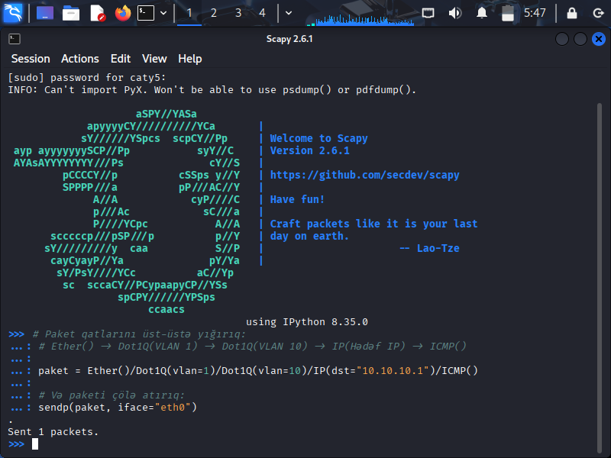

Step 2: Continuous Packet Injection Loop
To demonstrate the capacity to transmit continuous streams of raw traffic (simulating a potential Denial of Service or unauthorized payload streaming), a continuous loop structure was deployed via Scapy to execute packet injection at 0.5-second intervals. A total of 26 packets were successfully pushed to the link.
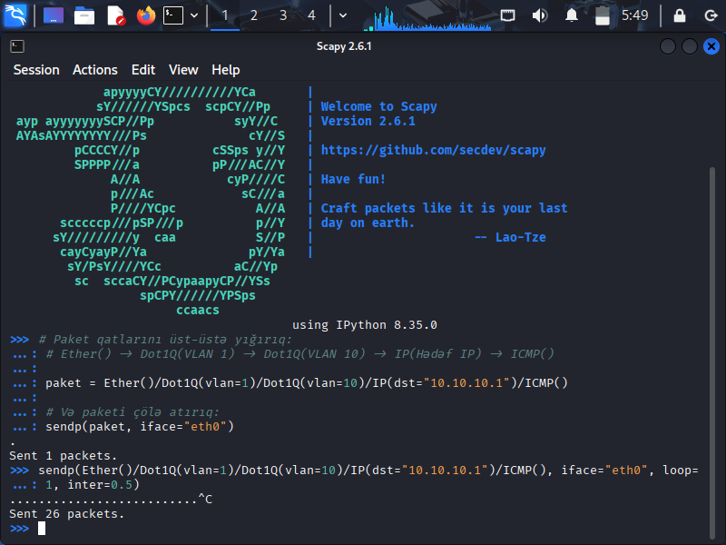

4. Analytical Observations and Limitations
- Unidirectional/Blind Traffic Limitations: This attack vector is strictly restricted to one-way communication (Blind Injection). Because the targeted host responds with normal single-tagged packets belonging to its native segment, upstream switches will not inject an outer Native VLAN tag on the return path. Thus, the traffic cannot dynamically route back to the attacker's console.
- Risk Impact Evaluation: Despite being a blind attack, it presents critical security concerns. Attackers can execute volume-based Denial of Service (UDP/ICMP Flooding) inside restricted zones or trigger pre-configured blind server-side vulnerabilities (such as Blind Remote Code Execution or specific Reverse Shells if egress filtering rules allow alternative outside routing).

5. Remediation & Hardening Guidelines
To completely eliminate the risk of VLAN Hopping within the switching infrastructure, the following defense-in-depth measures have been documented for implementation:
- Modify the Default Native VLAN Assignment: Change the standard Native identifier from the default VLAN 1 to an unroutable, completely isolated, and unused custom VLAN ID (e.g., VLAN 999).
- Enforce Explicit Tagging for Native Traffic: Force switches to explicitly tag all Native VLAN traffic passing through trunk ports to drop naked frames: switch(config)# vlan dot1q tag native
- Disable Dynamic Trunking Protocol (DTP): Ensure all user-facing edge access ports are statically declared and explicitly barred from dynamic configuration: switch(config-if)# switchport mode access switch(config-if)# switchport nonegotiate

